Fabulous Finishes
A good story ends in a way that leaves the reader with memories and feelings.
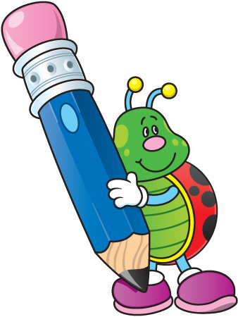
Types of Endings:
- End with a hope or a wish
- End with a thought or feeling
- End with a “quote” from your writing
- Give advice to the reader- something for them to go out and try
- Use humor to get the reader laughing
- Make a connection to self and your own life
- Confirm with the audience about what your story is about
- End with one final question

